**Step-by-Step AWS S3 Setup**



This guide will walk you through setting up and managing an EC2 instance on AWS.

# Step 1: Navigate to s3 Dashboard

Log in to your AWS Management Console and search for 'EC2' in the Services tab to open the EC2 dashboard.

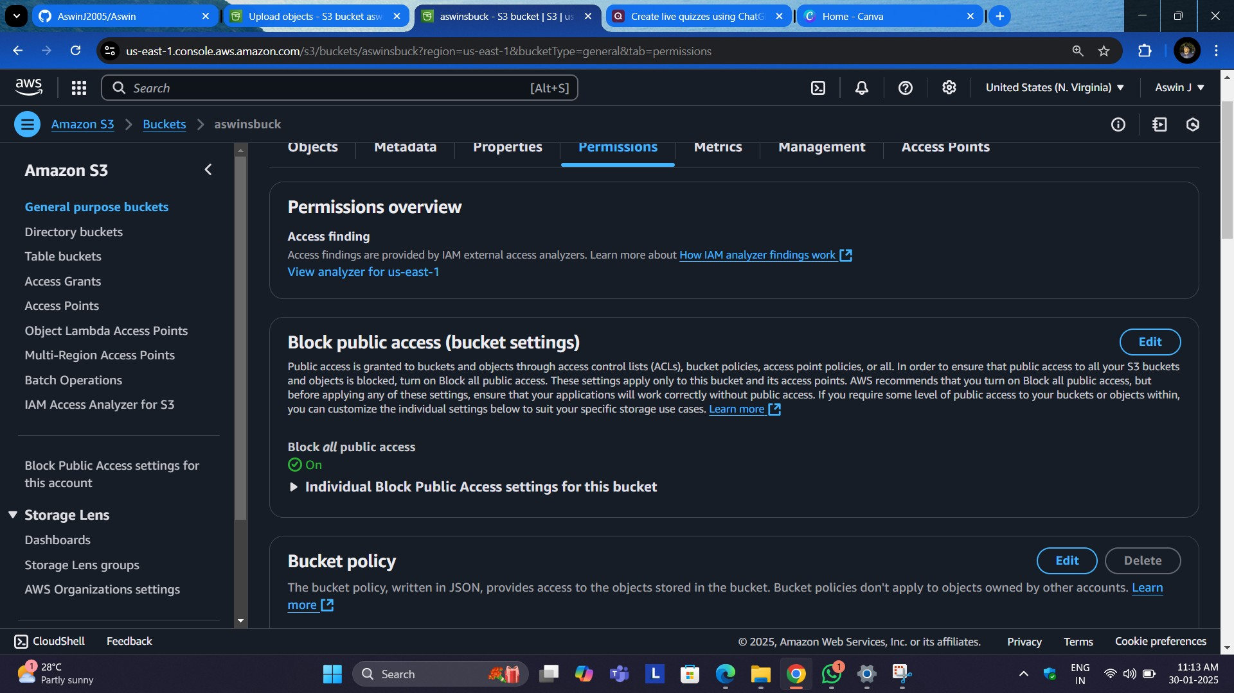

# Step 2: Launch an Instance

Click on 'Launch Instance' to begin setting up your virtual machine.

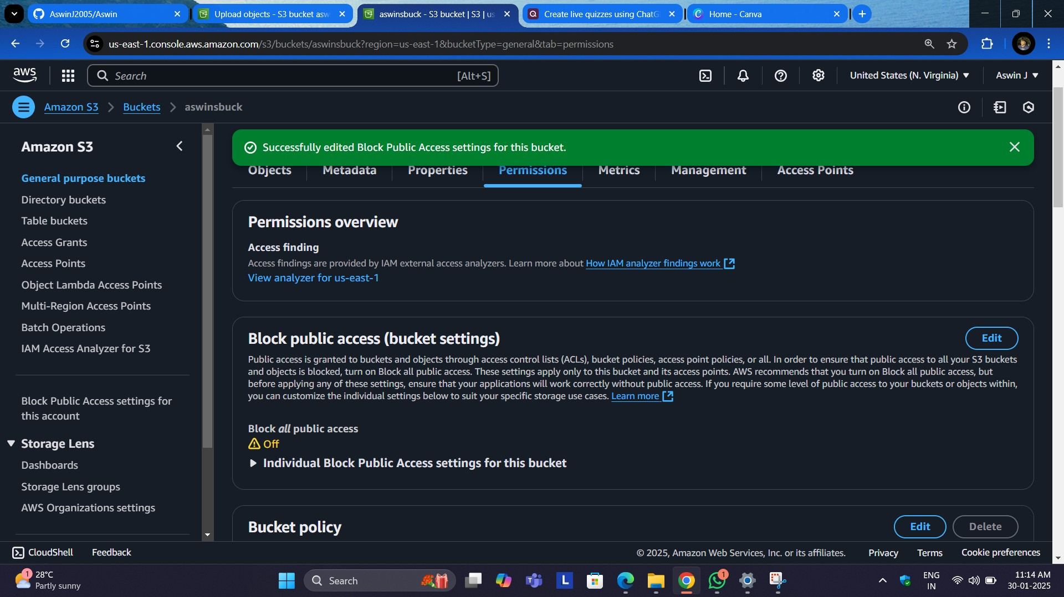

# Step 3: Choose an Amazon Machine Image (AMI)

Select a suitable AMI, such as Amazon Linux, Ubuntu, or Windows, based on your project requirements.

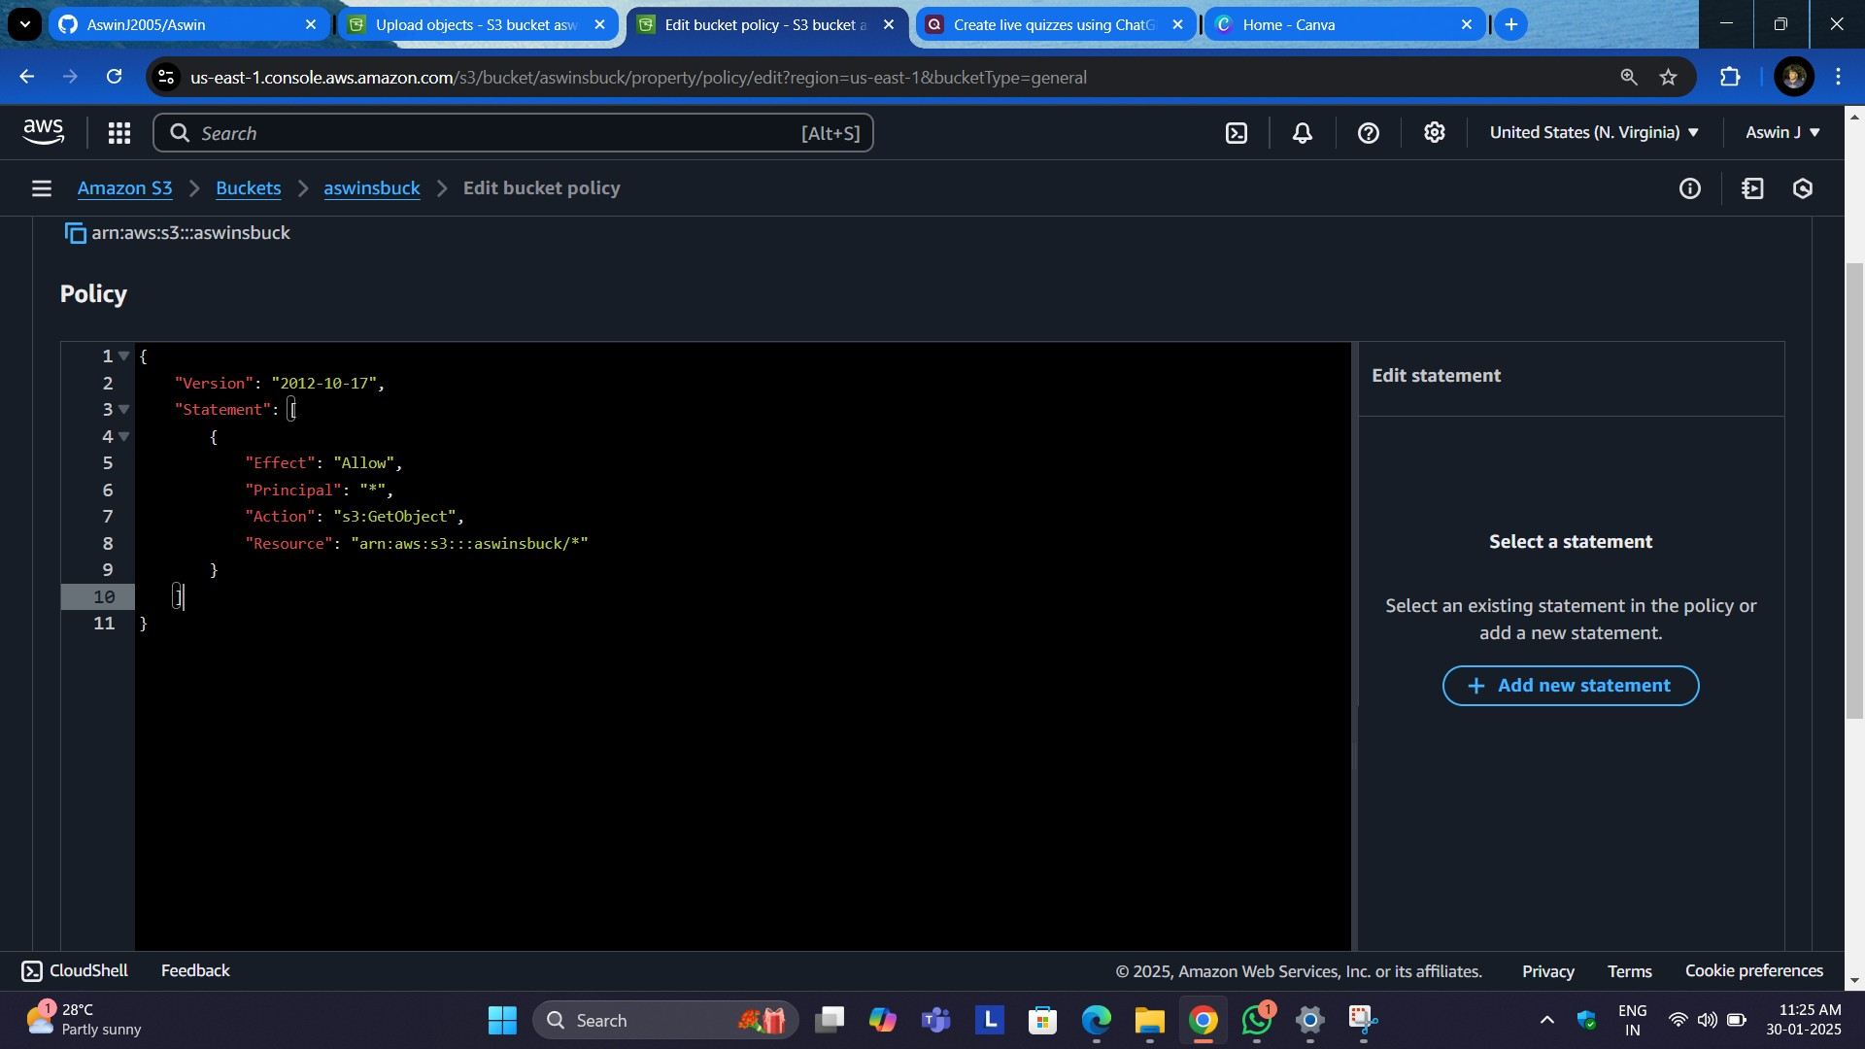

# Step 4: Choose an html Type

Pick an instance type depending on your required CPU and memory. For basic testing, the 't2.micro' type is recommended.

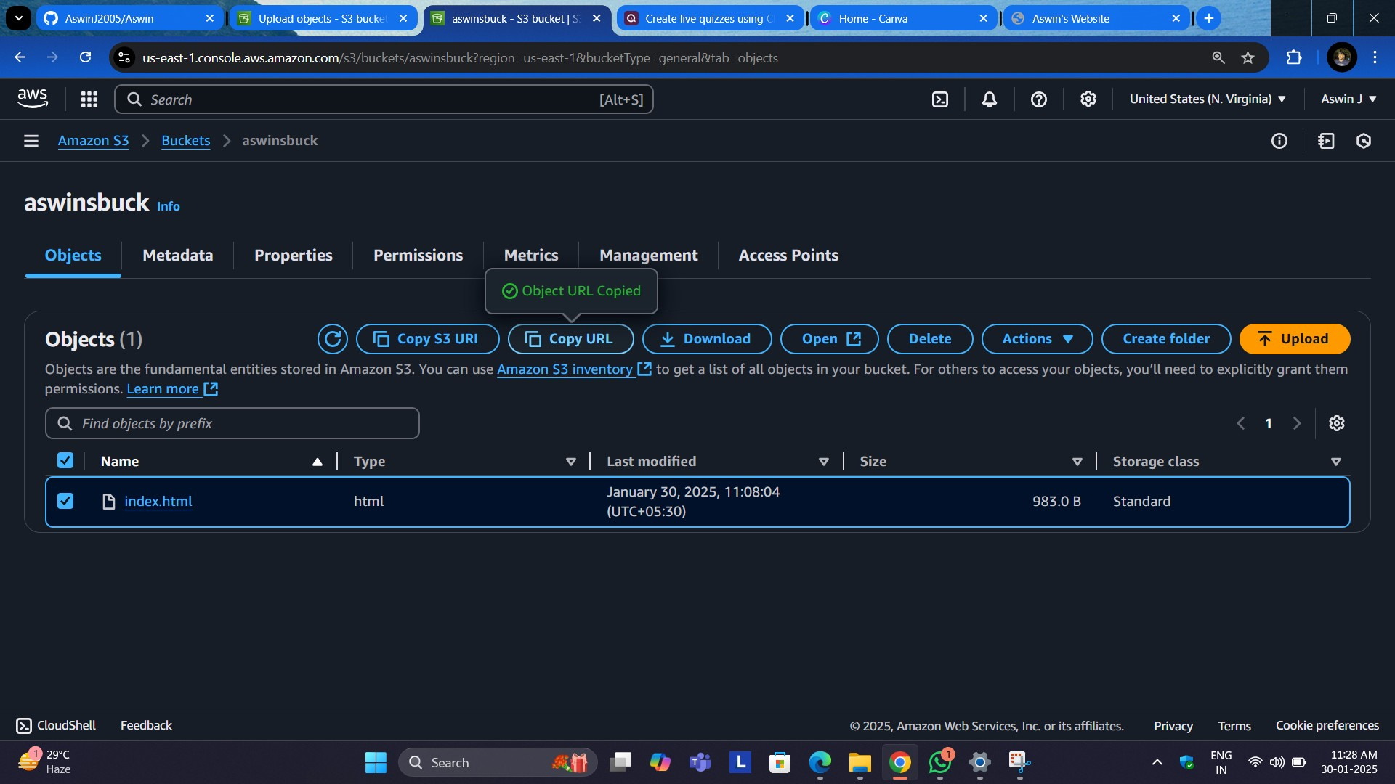

# Step 5: Copying And Paste the link

Customize network settings, enable public IP, and set IAM roles if needed.

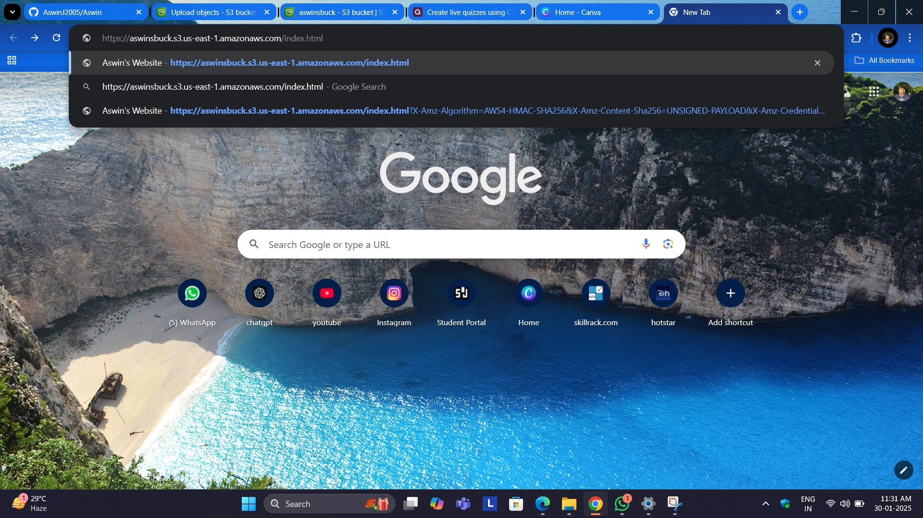

**Step 6: Add Storage**

Adjust the volume size and type as needed. Ensure to use the Free Tier eligible storage if applicable.

**Step 7: Configure Security Group**

Set inbound rules to allow traffic (e.g., SSH for Linux instances or RDP for Windows).

**Step 8: Review and Launch**

Review your configuration, then click 'Launch'. Create or select an SSH key pair and confirm launch.

**Step 9: Connect to Your Instance**

Use the 'Connect' option on the EC2 dashboard to SSH into your instance. For Windows, use RDP.

# Step 10: Terminate the Instance (Optional)

When finished, ensure you stop or terminate your instance to avoid charges.